***ARDUINO UNO LINUX***

Foto do projeto:

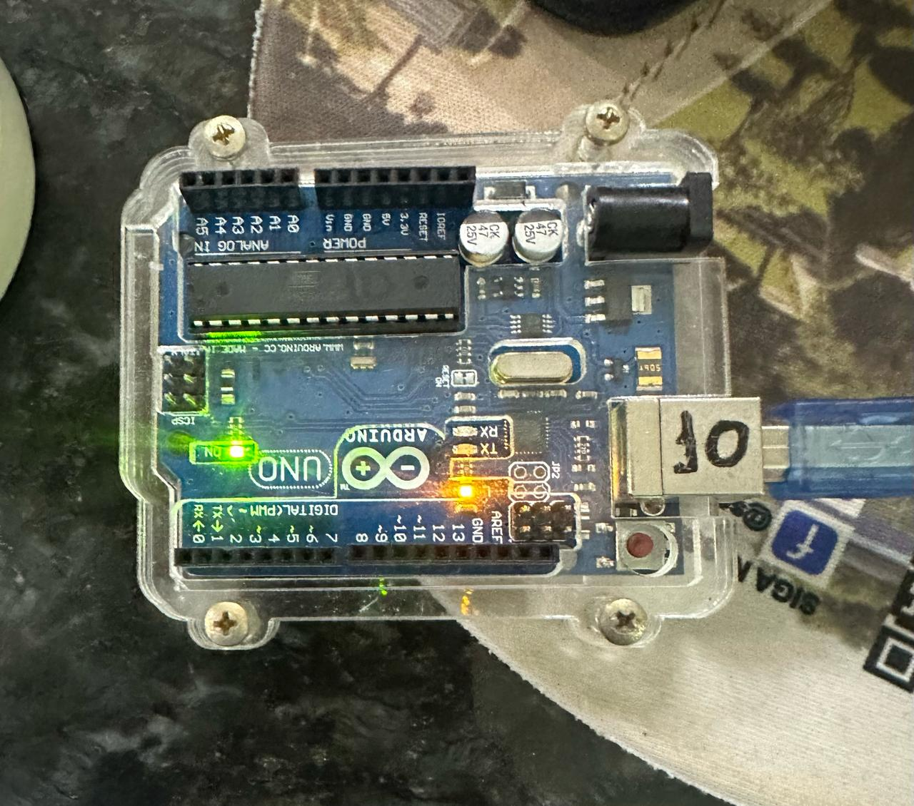

Programação:

/*

  Blink

  Turns an LED on for one second, then off for one second, repeatedly.

  Most Arduinos have an on-board LED you can control. On the UNO, MEGA and ZERO

  it is attached to digital pin 13, on MKR1000 on pin 6. LED_BUILTIN is set to

  the correct LED pin independent of which board is used.

  If you want to know what pin the on-board LED is connected to on your Arduino

  model, check the Technical Specs of your board at:

  https://www.arduino.cc/en/Main/Products

  modified 8 May 2014

  by Scott Fitzgerald

  modified 2 Sep 2016

  by Arturo Guadalupi

  modified 8 Sep 2016

  by Colby Newman

  This example code is in the public domain.

  https://www.arduino.cc/en/Tutorial/BuiltInExamples/Blink

*/

// the setup function runs once when you press reset or power the board

void setup() {

  // initialize digital pin LED_BUILTIN as an output.

  pinMode(LED_BUILTIN, OUTPUT);

}

// the loop function runs over and over again forever

void loop() {

  digitalWrite(LED_BUILTIN, HIGH);  // turn the LED on (HIGH is the voltage level)

  delay(1000);                      // wait for a second

  digitalWrite(LED_BUILTIN, LOW);   // turn the LED off by making the voltage LOW

  delay(1000);                      // wait for a second

}